Data Pane

**Relevant for: GUI** **testing, API testing, and business process testing**

**When should you use the BPT Data pane?** Use the Data pane to view and modify iteration data for your business component or group in your test or flow

UFT enables you to insert and run steps that are driven by data, including mathematical formulas, in the Data pane.

The Data pane shows the data related to the test or component, or business process testing flow. It displays the data in spreadsheet table with numbers of columns and rows which will be helpful in parameterizing that data.

To display the Data pane, select View > Data.

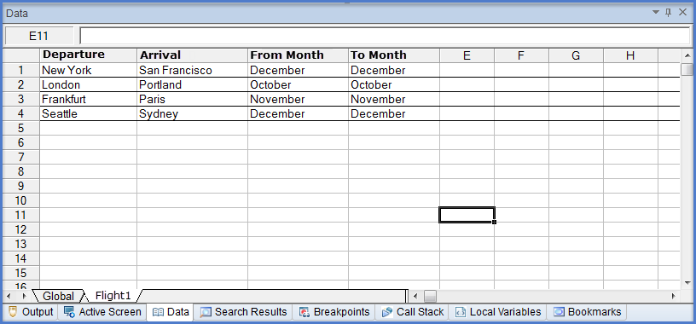

Data table content

Enter data top to bottom and left to right, leaving no gaps of entire rows or columns. Very large numbers in the data table may cause unexpected behavior. UFT does not support colors, formatting, and special cell formats.

Data table values

Values returned from the data table are always converted to strings. Use VBScript conversion functions to convert values to other types.

For example:

Window("Flight Reservation").WinComboBox("Fly From:").Select CInt(DataTable("ItemNumber", dtGlobalSheet))

Changing column headers

If you change a data parameter (column header), also update the relevant name of the parameter wherever else it is used, such as checkpoint or output values, or any ALM parameter mappings.

Importing Excel files to the Data Pane

Same as Data table in QTP, the Data pane has the characteristics of a Microsoft Excel spreadsheet, enabling you to store and use data in its cells and also perform mathematical formulas within the cells. You can use the GUI testing Data pane, or you can use any Microsoft Excel (.xls) file.

Regarding Microsoft Excel, the Excel files may be incompatible with UFT if they contains features or functionality unavailable for GUI tests. Special formatting in Excel files are not imported, and data is displayed in the Data pane with fixed values.

UFT does not support cross references to other Excel sheets.

So, importing excel files into Data Pane is useful in working because formatting will be imported, and data is displayed in the Data pane with values that can be changed.